**Redefining our goal:**

Annie:

* Overall Goal: Build a working prototype of an improved version of a low-cost ventilator
* Personal Goals: Contribute to an important project and see if we can get more traction to actually implement, Learn more about what goes into building a medical device that is functional in a hospital setting

Jacob:

* Overall: Help improve the current projects out there in order to aide corona-virus efforts
* Personal: Help others learn any new skills they are interested in learning :)
  + And to have a working device/prototype to be able to talk about in interviews or smt

Natasha

* Overall: Make modifications to develop a better working prototype of the ventilator splitter than what is currently offered
* Personal Goals: Apply the skills that I have in order to help others in a short amount of time and be able to help prototype a medical device.

Hannah:

* Overall Goal: Help build a low-cost ventilator that can potentially be used to help people
* Personal Goal: Learn more about how to make a medical device and be able to gain new skills that I don’t currently have (particularly the more mechanical engineering side of medical devices)

**Questions we don’t know the answer to:**

1. **General**: how can we measure pressure in a ventilator tube using a barometric pressure sensor?
2. What’s the best way to measure pressure in this situation?
3. What kind of pressure sensor should we use?
4. Can we use a pitot tube to do this? If so, how do we measure static and dynamic pressure?

**Action Items:**

* What is the desired accuracy for pressure measurements in a medical device?

**Notes**:

* Can we use a flow sensor and convert to pressure?
  + The **pressure** drop across the **meter** is proportional to the square of the **flow** rate (i.e., the square root of the **pressure** differential).
* <https://e-vent.mit.edu/controls/electrical-hardware/>
* How to solve for pressure using the bernoulli equation
  + <https://demonstrations.wolfram.com/MeasuringFlowRatesWithAPitotTube/>
* Pitot Tube video <https://www.youtube.com/watch?v=AMNXdiSd01c>
* Static Pressure - measure before air flow then calibrate
* <http://rc.rcjournal.com/content/respcare/early/2014/10/21/respcare.03410.full.pdf>
* <https://www.freecodecamp.org/news/programming-the-electronics-for-covid-19-ventilators/>
* <https://www.ni.com/en-us/innovations/white-papers/11/pressure-measurement-overview.html#section--1536767137>

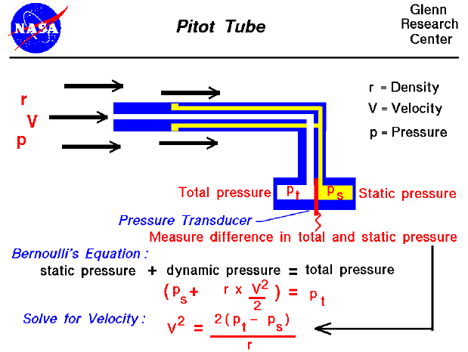

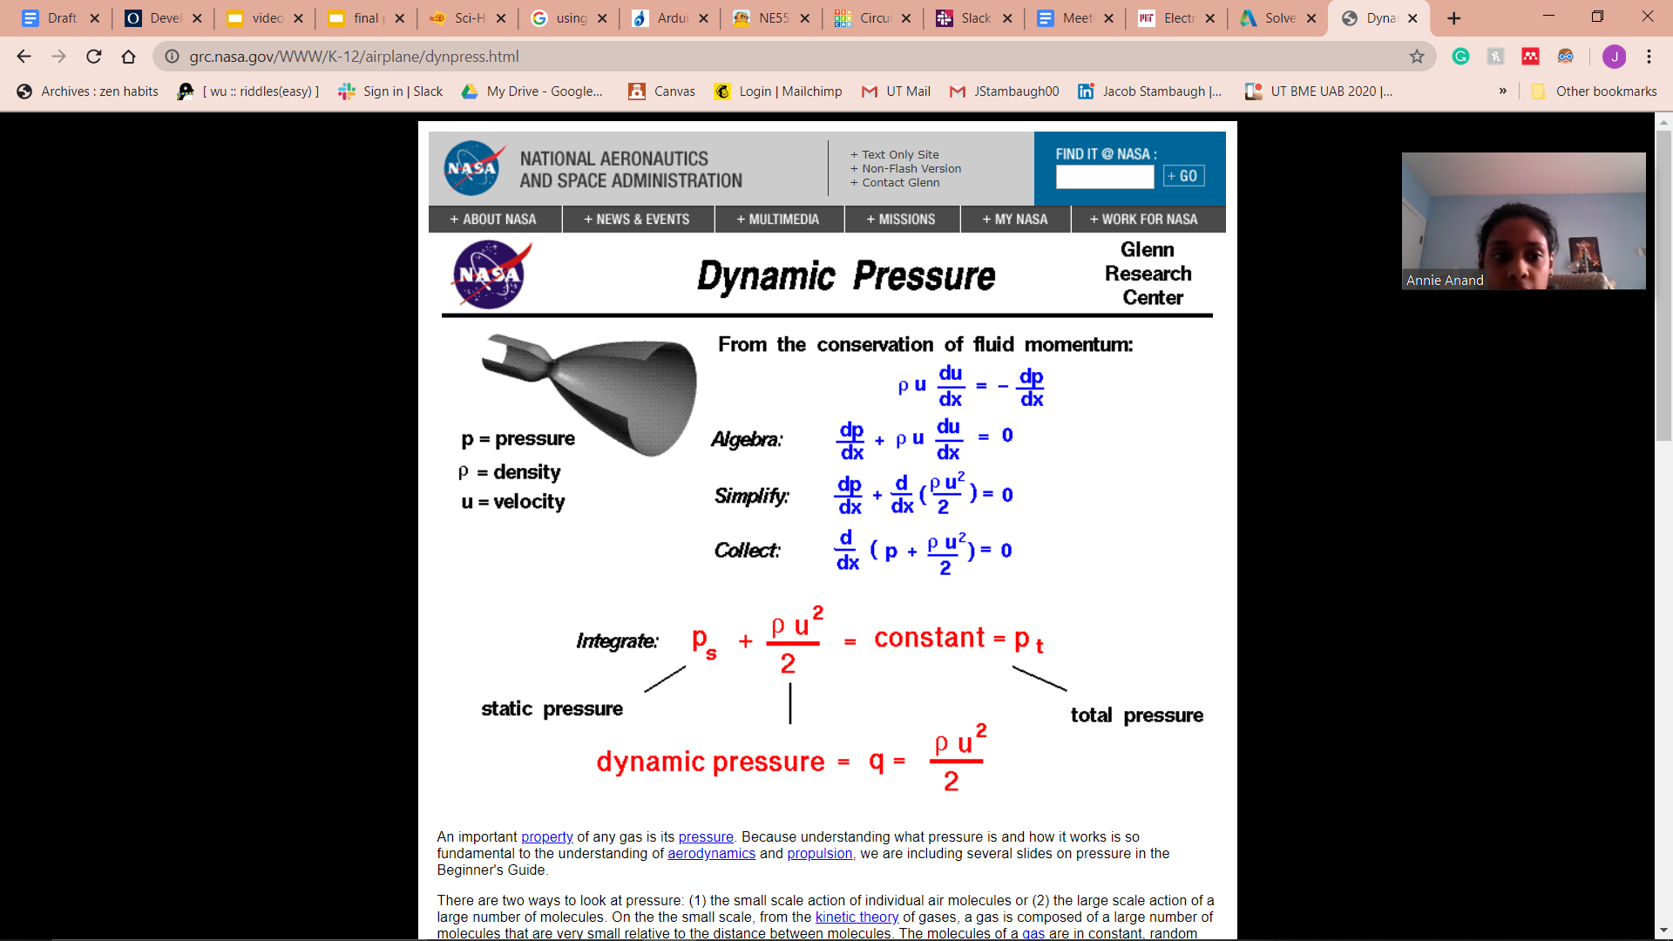

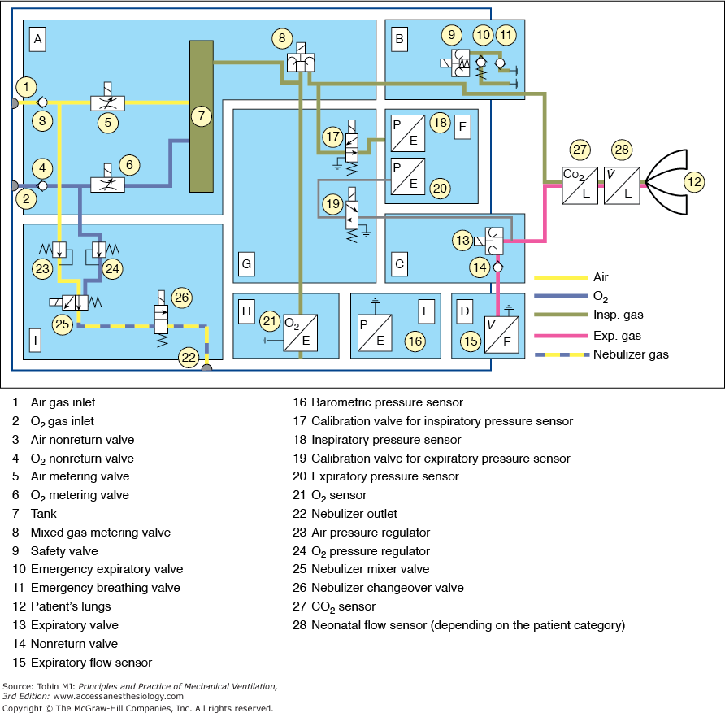

<https://accessanesthesiology.mhmedical.com/content.aspx?bookid=520&sectionid=41692239>

Additional Information on the physiology of respiration (could help us determine the difference in pressure we want to detect)

* <https://opentextbc.ca/anatomyandphysiology/chapter/22-3-the-process-of-breathing/>

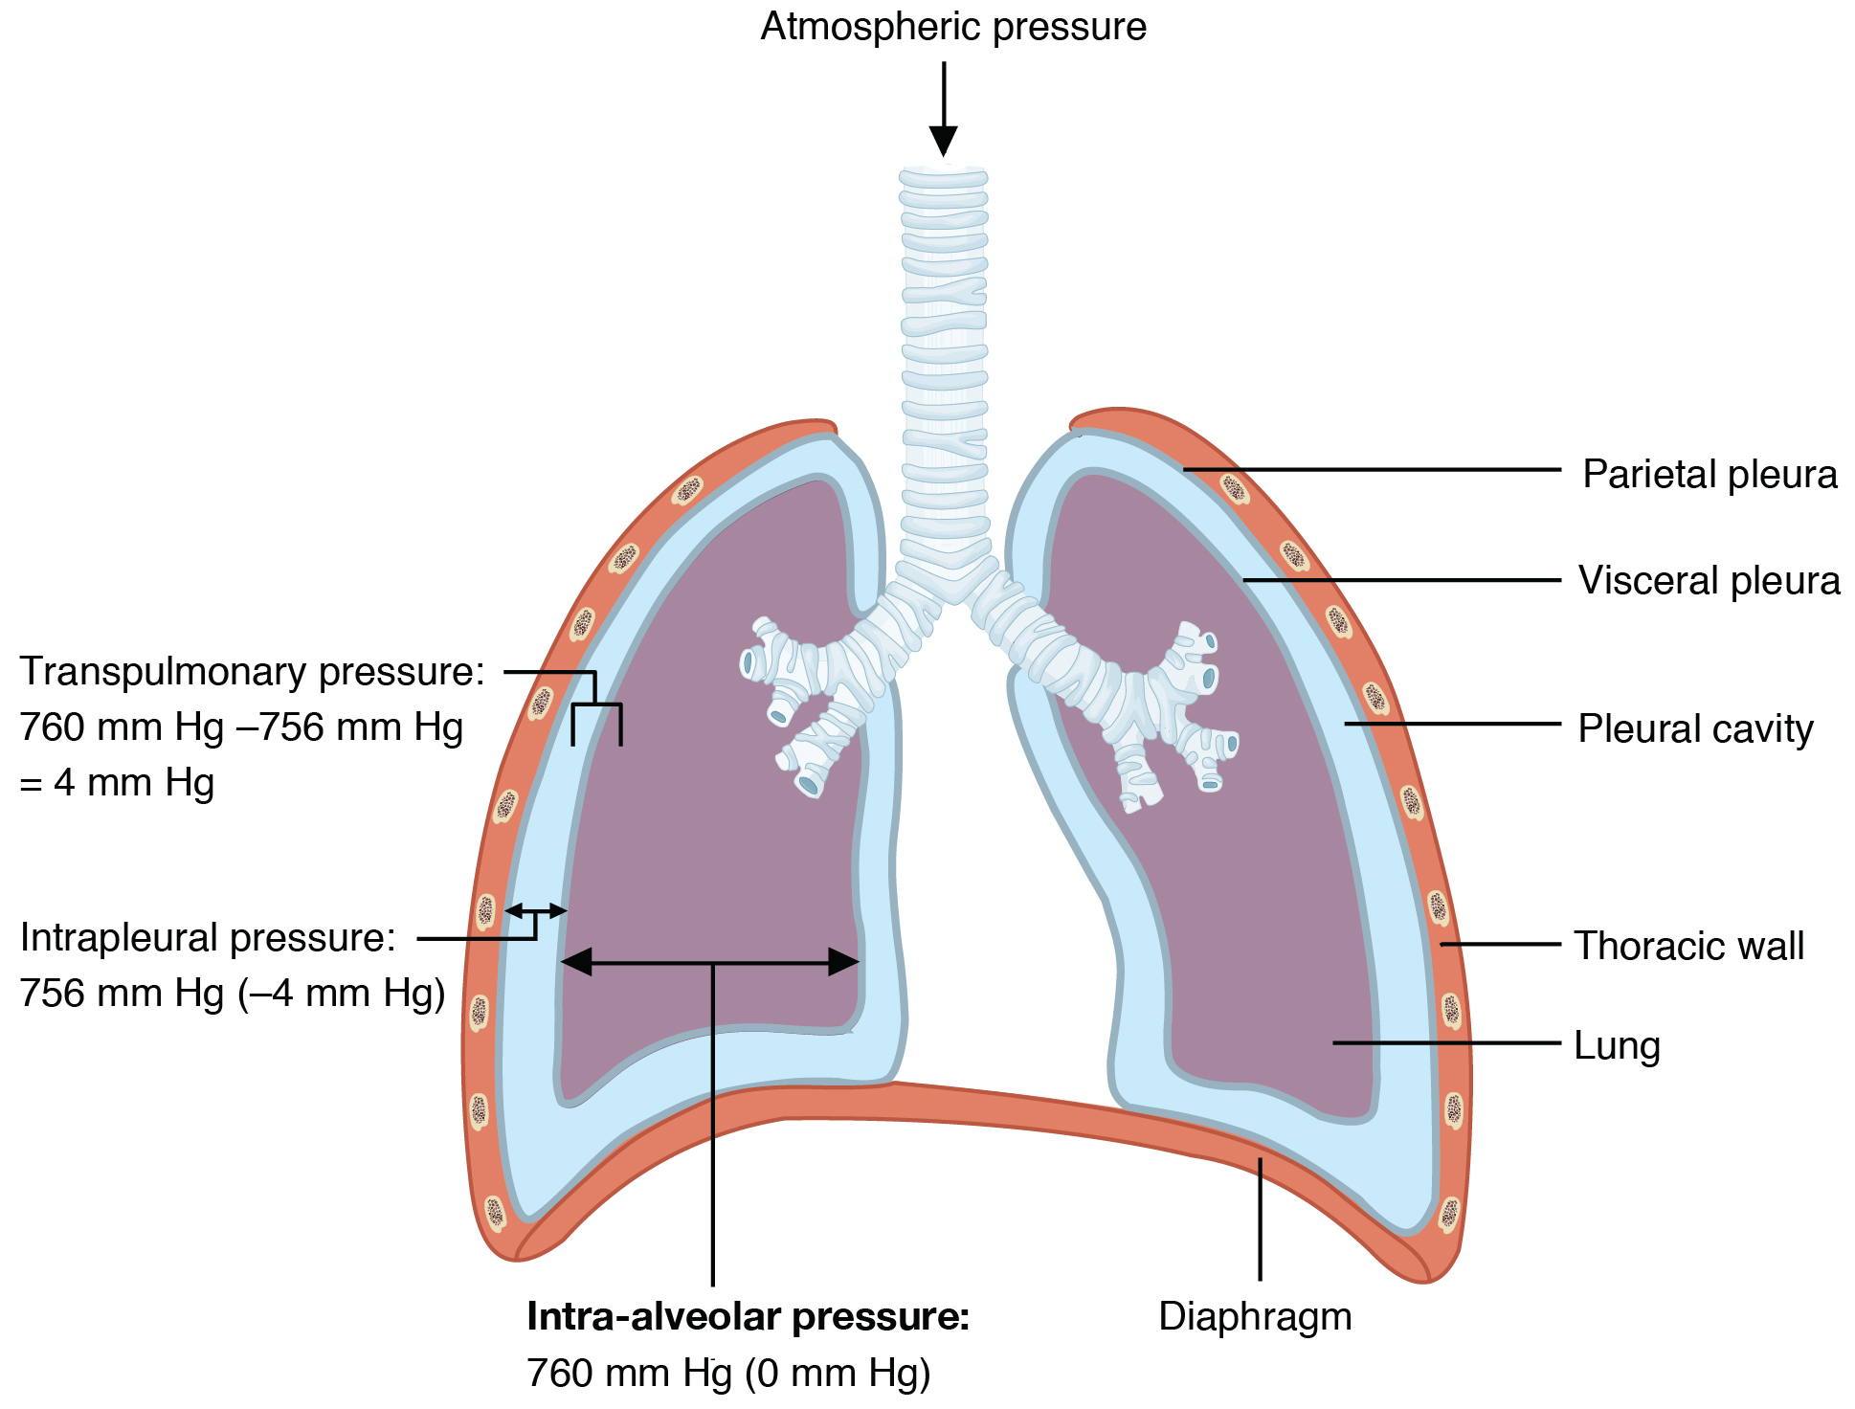

<https://www.kumc.edu/AMA-MSS/Study/phys3.htm>

* Inspiration: Pleural pressure changes from about -5 to -8 cm H2O, varies by compliance fo the lung
* Expiration: if forced, the pleural pressure can actually become positive, otherwise normal respiration is just the relaxation of the diaphragm.
* ***TOTAL DeltaPRESSURE = (PATM - PALV) + (PALV - PPLU) = DeltaPFLOW + DeltaPTRANSPULM***
  + **(PATM - PALV) = TRANSAIRFLOW PRESSURE**: *The pressure difference between the atmosphere and alveoli determines* ***airflow***.
    - **DeltaP = (PATM - PALV) = (Airflow) x (Resistance)**
    - The higher the flow, the higher the pressure; the higher the resistance for an equivalent flow, the higher the pressure required to overcome that resistance.

*Applying this to ventilated patients:* [*http://rc.rcjournal.com/content/59/11/1773*](http://rc.rcjournal.com/content/59/11/1773)